Software Design Approaches - Bottom-Up

📖 Definition
# Source: AI Source: Provided by: [Data Path: Persons Table -> ID Column: 1, Name_En Column: Motasem Essam] -> From: [ChatGPT] on [1/23/2026]
The Bottom-Up Design Approach is a method where development starts with small, basic components (modules) and gradually integrates them to form a complete system.
👉 In simple terms:
“Start small, then build up to the whole system.”

⚙️ How It Works
# Source: AI Source: Provided by: [Data Path: Persons Table -> ID Column: 1, Name_En Column: Motasem Essam] -> From: [ChatGPT] on [1/23/2026]
- Identify and develop basic building blocks (modules)
- Test these modules individually
- Combine modules into larger subsystems
- Integrate subsystems to form the complete system

🧩 Key Characteristics
# Source: AI Source: Provided by: [Data Path: Persons Table -> ID Column: 1, Name_En Column: Motasem Essam] -> From: [ChatGPT] on [1/23/2026]
- Focuses on low-level components first
- Encourages code reusability
- Modules are developed and tested early
- System structure emerges gradually

✅ Advantages
# Source: AI Source: Provided by: [Data Path: Persons Table -> ID Column: 1, Name_En Column: Motasem Essam] -> From: [ChatGPT] on [1/23/2026]
- Early testing: Bugs are found at the component level
- Reusability: Modules can be reused in other systems
- Flexibility: Easier to adapt to changes
- Parallel development: Teams can work on different modules simultaneously

⚠️ Disadvantages
# Source: AI Source: Provided by: [Data Path: Persons Table -> ID Column: 1, Name_En Column: Motasem Essam] -> From: [ChatGPT] on [1/23/2026]
- Lack of overall structure initially
- Integration can be complex and time-consuming
- May require redesign when combining modules
- Not ideal if system requirements are very clear from the start

🎯 Use Cases
# Source: AI Source: Provided by: [Data Path: Persons Table -> ID Column: 1, Name_En Column: Motasem Essam] -> From: [ChatGPT] on [1/23/2026]
- Systems with reusable components or libraries
- Projects where requirements evolve over time
- Agile or iterative development environments
- Component-based and modular systems

🛠️ Simple Example
# Source: AI Source: Provided by: [Data Path: Persons Table -> ID Column: 1, Name_En Column: Motasem Essam] -> From: [ChatGPT] on [1/23/2026]
Problem: Build an Online Shopping System
Step 1: Build Small Modules
- Login Module
- Product Display Module
- Cart Calculation Module
- Payment Processing Module
Step 2: Combine Modules
- Integrate Login + Product Display → User Interface
- Integrate Cart + Payment → Checkout System
Step 3: Final System
- Combine all subsystems → Complete E-commerce Platform

🔄 Bottom-Up vs Top-Down (Quick Insight)
# Source: AI Source: Provided by: [Data Path: Persons Table -> ID Column: 1, Name_En Column: Motasem Essam] -> From: [ChatGPT] on [1/23/2026]
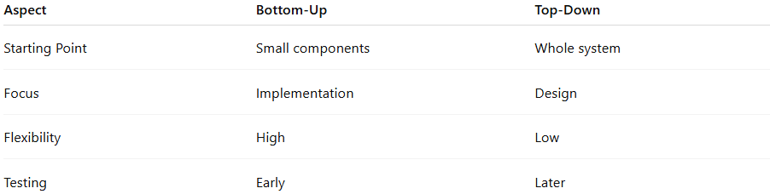
Aspect | Bottom-Up | Top-Down
Starting Point | Small components | Whole system
Focus | Implementation | Design
Flexibility | High | Low
Testing | Early | Later

📌 Summary
# Source: AI Source: Provided by: [Data Path: Persons Table -> ID Column: 1, Name_En Column: Motasem Essam] -> From: [ChatGPT] on [1/23/2026]
The Bottom-Up Design Approach builds software by starting with small, reusable components and integrating them into a complete system. It is highly flexible and supports early testing and parallel development, but may lack a clear overall structure in the early stages and can lead to integration challenges later.

